CSA0501-DATABASE MANAGEMENT SYSTEMS
LAB EXPERIMENTS DATE: 21-08-2026

EXPERIMENT 17 - HIGH LEVEL PROGRAMMING EXTENSIONS – FUNCTIONS

AIM:

To implement and execute user-defined functions and recursive procedures in MySQL using the INTERN table.

.PROCEDURE:
- Select the INTERN database.
- Change the delimiter using DELIMITER //.
- Create a function using CREATE FUNCTION.
- Define the return datatype and required conditions.
- Restore the delimiter.
- Execute the function using a SELECT statement.
- Set the recursion depth for the recursive procedure.
- Create a recursive procedure to calculate the factorial of a number.
- Execute the procedure using CALL.

PROGRAM 1-FUNCTION:

DELIMITER //

CREATE FUNCTION GetInternLevel(p_age INT)
RETURNS VARCHAR(20)
DETERMINISTIC
BEGIN
DECLARE intern_level VARCHAR(20);

IF p_age <= 20 THEN
SET intern_level = 'JUNIOR';

ELSEIF p_age <= 22 THEN
SET intern_level = 'INTERMEDIATE';

ELSE
SET intern_level = 'SENIOR';
END IF;

RETURN intern_level;
END //

DELIMITER ;

SELECT InternID, InternName, Age,
GetInternLevel(Age) AS Intern_Level
FROM INTERN;
OUTPUT:
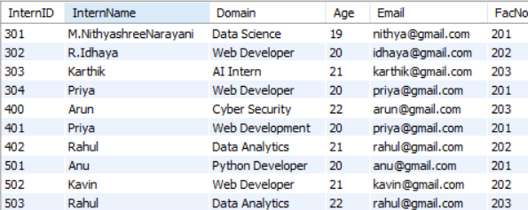

PROGRAM 2 – RECURSIVE PROCEDURE:
SET @@SESSION.max_sp_recursion_depth = 255;

DELIMITER //

CREATE PROCEDURE CalculateFactorial(
IN n INT,
OUT result BIGINT
)
BEGIN
IF n <= 1 THEN
SET result = 1;
ELSE
CALL CalculateFactorial(n - 1, @temp);
SET result = n * @temp;
END IF;
END //

DELIMITER ;

CALL CalculateFactorial(5, @result);

SELECT @result AS Factorial;
OUTPUT:
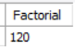

RESULT:
Thus, the user-defined function was successfully created and executed to determine the intern level based on age, and the recursive procedure was successfully implemented to calculate the factorial of a number.

